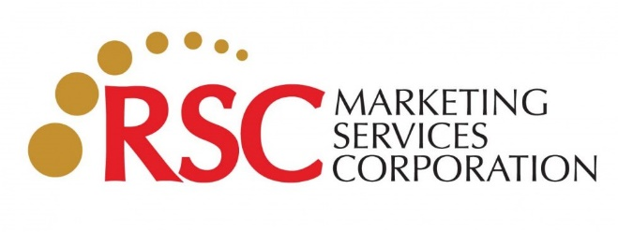
RESEARCH BRIEF
Rm. 209-A State Condo V, 452 EDSA Guadalupe, Makati City, Philippines
Tel. No.: 8896-10-59
www.rsc.ph

Background of the study: What prompted the need for Market Research? Include existing historical data and relevant background information that will help drive understanding of the research need.

Research Objectives and Information Needs: What is the primary objective of this research? What are the secondary objectives, if any? You may list specific questions that are relevant to this study, i.e. information needed to make marketing decisions.

Action Statement and/or Action Standard(s): What decisions will be made using the information and insights gathered from this study?

Target Consumers: What consumer segment(s) is the product/communication targeting? This should include demographic profile, as well as consumption requirements

Method and Extent:

Methodology:

- Type of Study:

- Area of coverage: (Which region – GMA, NOL, SOL, Vis, Min, or specific cities)

